**Tipping Bucket Calibration Protocol**

*Last Updated February 6, 2015 by Aaron Bugaj*

*Before calibrating any of the tipping buckets for a LEO hillslope it is essential to perform a routine maintenance check for all collection funnels, tubing, flow meters, and tipping buckets in each LEO hillslope drainage system.

*What to look for:*

* Look for gravel lodged in the white collection funnels where the slope seepage drains into the flow meter and tipping bucket manifold.
* Disconnect the black tubing that runs into the flow meter and run water through the tubing to check for lodged gravel.
* Make sure the water passage through the flow meter is all clear.
* Look for water leaks in the flow meter and pvc connections.
* Make sure tipping buckets have tipping mechanisms that are tipping properly. Take the grated funnel off the bucket and check that the magnetic strip connected to the tipping mechanism does not rub against the mounting plate for the magnetic reader.
* Check to make sure that external screws on the tipping buckets have screws to prevent water loss through open holes.

**Calibration:**

*You will need:*

* An empty 5 gallon bucket
* A Large funnel (I used the ones that were already in place under the tipping buckets, just make sure that the holes are covered up with tape during calibrations to limit leaking)
* A pvc pipe to connect funnel under tipping bucket to the 5 gallon collection bucket below.
* A scale
* A water source (hose)

We are interested in tipping bucket calibrations so that we have a resource for measuring low flow seepage for our hill slope drainage when the flow rate of the seepage is too low for the flow meters to accurately measure. Thus, we perform tipping bucket calibrations to create a curve that spans several low flow rates so that we can use tip counts to get consistent flow rate estimates at low flow.

You should calibrate the tipping buckets with *at least* three different flow rates (I used approximately 0.2 l/min, 0.5 l/min, and 1.0 l/min).

1. Open the LEO Drainage Calibration Tool on the main computer underneath the Center LEO Hillslope.
2. Clear any cumulative volume readings that were already on the tool so that all of the windows on the Drainage Calibration reader board read “0”. You will likely have to clear the cumulative volume many times as you go through calibrations.
3. Use pvc piping and a funnel to run the tipping bucket’s drainage into your 5 gallon bucket as shown below. Be sure that the funnel is secure and that the all drainage from the tipping buckets goes into the funnel, no spilling.

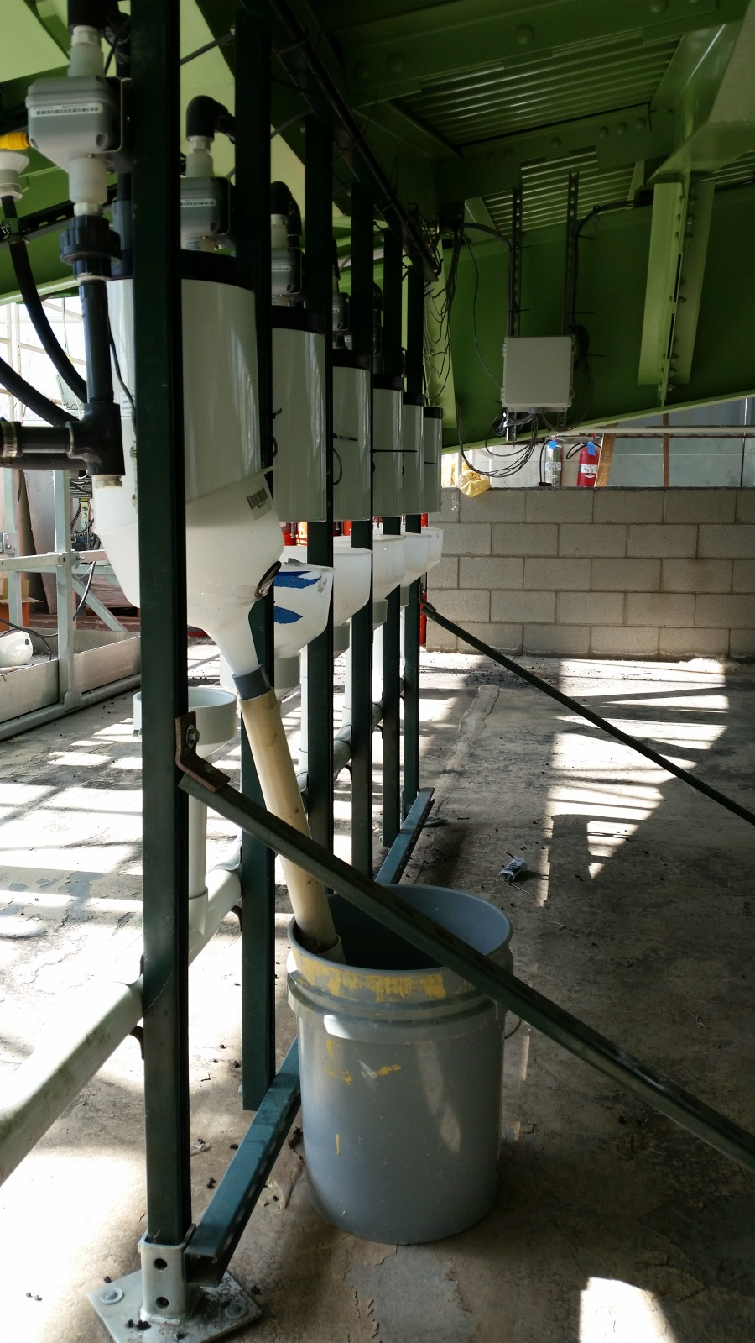

1. Next, adjust the water pressure on the hose valve to get your ideal flow-rate. Flow should be controlled from the fixed hose valve at closed end of the hose. Use a 5-gallon bucket and a large kg scale to adjust your flow-rate. Fill the bucket with water for a minute at a steady flow-rate and weigh the bucket in kg. The conversion of 1L=1kg will allow you to find your desired flow rate in liters/min.
2. Once you have your desired flow rate running out of the hose, use an alligator clip to prop the hose up so that it feeds into the white collection funnel just below the hill slope drainage pipe for the tipping bucket that you wish to calibrate. As soon as the water is running, start the time on a stopwatch so you can measure your final collected output over time to get a “bucket check” flow rate that will be used for the calibration.



*Figure 1: Raw data from calibration of West Hillslope 1/30/15*

1. After 5 minutes, or your allotted flow time, take the hose out of the collection funnel. Retrieve the 5-gallon bucket that should be filled with some volume of water and weigh it on the scale. Record your weight, time, counts, and PE102 cumulative volume on an excel spreadsheet (as above). You can calculate a flow rate for the flow meter and a bucket flow rate using their respective cumulative volumes.
2. Once all data is collected and recorded in an excel spreadsheet, us the TB CAL Template to create individual calibration graphs for each bucket that will serve as a go-to in the case that one of our tipping buckets fails during experimentation. Also included on the LEO Wiki Page is a completed calibration spreadsheet titled “TB CAL 2015 Examples.xlsx” which can serve as a reference during calibrations.